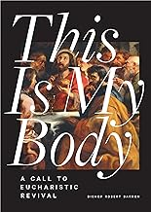

**THIS IS MY BODY**

**A Call to Eucharistic Revival**

**BISHOP ROBERT BARRON**

**Copyright © 2023 by**

**Word on Fire Catholic Ministries**

**Published by Word on Fire**

**Elk Grove Village, IL**

**Transcription of ISBN:**

**978-1-685789-97-8**

**Transcribed 2024 in UEB by**

**Terrence McCafferty**

**Xavier Society for the Blind**

**248 W. 35th Street, Suite 1502**

**New York, NY 10001**

**In 2 Volumes**

**Volume 1**

**Braille pages t1-t4, p1-p4, 1-104**

**Print pages ii-vii, 1-68**

